1st Semester’s “Need to knows” of Biology

Nature of Science/Introductory Concepts to Biology
Standard: N.2.1 Students are able to apply science process skills to design and conduct student investigations.
Skill: Scientific Methods
- The general purpose of the Scientific Methods

- The essential steps of the Scientific Methods are? Is there a set order to these steps?

- Definition of Hypothesis and the correct way a hypothesis needs to be written.

- Hypothesis do not always needs to be correct, but all hypothesis’ should be written in a way that they can be ___________________ during an experiment.

Skill: Experimental Parts/Design
- Experiments are used to test a scientific hypothesis. What has to be done to make an experiment valid in the science world?

- Define variables in terms of scientific experiments.

- Dependent, independent, control, and constant variables are all very important parts of an experiment. Explain each type and what each variable is used for in the experiment.

  - Dependent:
  - Independent:
  - Control:
  - Constant:
- Experiments/observations lead to a lot of great data being collected. What is data and what is used to collect this data?

- Quantitative and Qualitative are two types of data being collected during an experiment/observation. Compare and contrast the two types of data.

Skill: Graphing
- Graphing is very important in displaying data collected during scientific experiments/observations. When setting up graphs in science what variables from the experiment will be graphed? What axis of the graph will each be put on in general terms?

- Explain what type of data is best shown through the use of a bar graph, and what type a data comparison is best shown using a line graph in science.

Chemistry of Life/Biochemistry
Standards:
- SD P.1.2 Students are able to describe ways atoms combine.
- SD L.1.1 Students are able to relate cellular functions and processes to specialized structures with in the cell.
Topic: Properties of Water
- Describe a single molecule of water. Label the regions of the molecule that are polar with the correct charge.
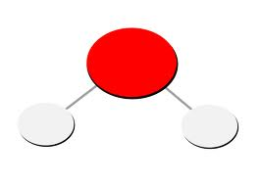

- Explain why water molecules have these polar charges and where the Hydrogen bonds form.

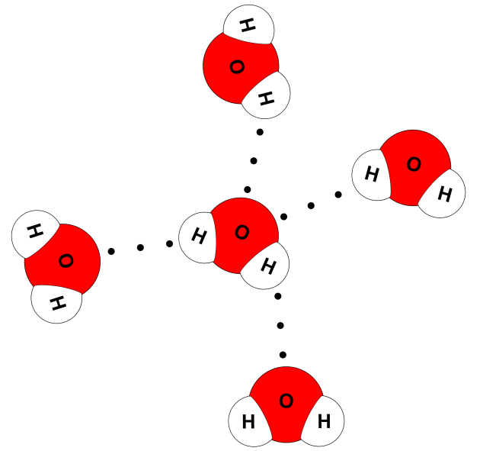

- The Hydrogen bonds of water give water itself three important properties essential to all living organisms. What are these three properties and describe each

  - .
  - .
  - .

Topic: Carbon Properties

- Carbon is said to be the element essential for life. It is a very important element due to its ability to __________________________________________________________.

- What are the 4 Carbon based molecules found in all living organisms? List each and write a brief description of the function each molecule has. Also sketch an image of what a monomer of each molecule will look like.

Topic: Solutions/mixtures
- Define solution:
- Define solvent:
- Define Solute:
- Sketch an image and label the solution, solute, and solvent.

- Some compounds break up when they dissolve in water. The amount of H+(hydrogen ions) a solution contains is measured by what scale?

- Sketch the pH scale and explain which direction from neutral 7 would be an acid and which direction from neutral 7 would be a base. (Know what the H+ concentration will be of each).

Topic: Chemical Reactions
- Define Chemical Reactions:
- Chemical equations are used to show what happens during a chemical reaction. Look at the example below and label the different parts. (Reactants, direction of reaction, and products)
6CO₂ + 6H₂O C₆H₁₂O₆ + 6O₂

- If a reaction has a double arrow (one pointing in both directions) what does this represent?
- Define Activation Energy:
- Define Endothermic Reactions:
- Define Exothermic Reactions:

Topic: Enzymes
- Enzymes are catalysts. Define Catalyst:

- What affect do enzymes have on chemical reactions?

- Define Substrates:

- What and/or how does a change in temperature or a change in pH, change how an enzyme may work?

Cellular Structure and Function
Standard: Students are able to relate cellular function and process to specialized structures within cells.
Topic: Cell Theory
- Most important invention linked to all knowledge gained about the cell is the…?

- List the three major principles of the cell theory.

  - –
  - –
  - –
Topic: Types of Cells
- Define Prokaryotic cell:
  - Examples:
  - DNA is found:
- Define Eukaryotic cell:
  - Examples:
  - DNA is found:
- Two types of eukaryotic cells are plant and animal cells. What are the important characteristics of each?
 | Cell Wall | Cell Membrane | Chloroplast | Mitochondria | Large Central Vacuole
Pant Cell

Animal Cell

Topic: Cell Structure

- Know the function/jobs of each of the following organelles found in a common cell
Nucleus
Mitochondria
Chloroplast
Endoplasmic Reticulum
Vesicles
Ribosomes
Vacuoles
Golgi Apparatus
Cytoplasm
Cytoskeleton

- Function of Cell Membrane:
- Draw and label parts of phospholipid. Be sure to show the polar region and non polar region.

- Scientist developed a model to describe the arrangement of molecules that make up the cell membrane. This model is called the _________________________________________.

Topic: Transport of Materials
- Define Passive Transport:
  - Types of Passive Transport
    - –
    - –
    - –
- Define Active Transport:
  - Types of Active transport
    - –
    - –
    - –
- Define Concentration Gradient:

- Types of solutions:
  - Isotonic water moves in what direction:
  - Hypertonic water moves in what direction:
  - Hypotonic water moves in what direction:

Cellular Energy
Standard: Students are able to relate cellular functions and process to specialized structures within cells.
Topic: ATP
- Define ATP:
- Define ADP:
- What is the role of ATP?
- Draw and label the structure of ATP. Show which phosphate group will be removed to release the energy during dephosphorylation.

Topic: Energy Production Photosynthesis
- Define autotrophs:
- Define Photosynthesis:
- Formula of Photosynthesis (Label reactants and products):

- Light dependent(photosystems) Reaction main function:

- Light independent Reactions (Calvin Cycle) main function:

Topic: Energy Production Cellular Respiration
- Define heterotrophs:
- Define Cellular Respiration:
- Formula of Cellular Respiration (Label reactants and products)

- Cellular respiration is said to be a ______________________________ of photosynthesis.
- Order of Cellular Respiration Steps(know the products and function of each).
  - –
  - –
  - –

- Glycolysis and the Krebs cycle both release what molecule?

- Define Glycolysis:

Topic: Energy Production without oxygen
- Define Fermentation:
  - Types of Fermentation
    - –
      - Products:
      - Uses:
    - –
      - Products:
      - Uses:

Cellular Division
Standard: SD L.1.1 Students are able to relate cellular functions and process to specialized structures within cells.
Topic: Cell Cycle
- List the correct order of the cell cycle.
- Label and explain what happens in each phase of the cell cycle.

- What parts of the cell cycle fall under interphase? Draw an arrow around the sections above that fall under interphase.
- If a cell doesn’t pass the check point where does go?

Topic: Chromosomes
- Label the parts of the chromosome
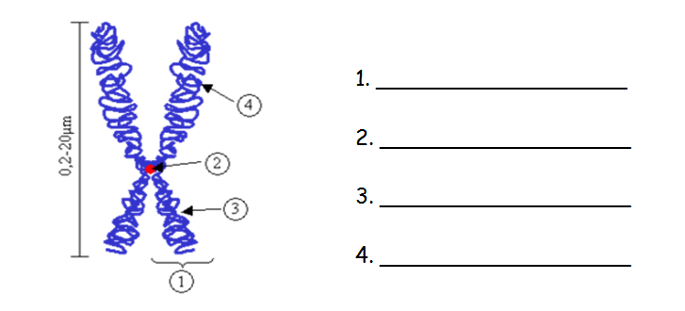

- What are Chromatids?

- What are homologous chromosomes?

Topic: Mitosis
- What type of cell goes through the process of Mitosis?

- What is the term used to describe the two genetically identical cells created in one round of mitosis?

- Describe and sketch what each of the following stages look like during mitosis and the key items to look for to identify which stage the cell is in.
Prophase Metaphase Anaphase Telophase Cytokinesis

- Describe the roles of both the centrioles and spindle fibers through-out the process of mitosis.

- Are the cells produced through Mitosis somatic cells or gametes?

- How many copies of each chromosome will the cell produced have after the process of Mitosis is finished? Does this make the cell diploid or haploid? Why?

- How many total chromosomes will a human somatic cell have after the process of Mitosis?

- How many cells are produced during a round of Mitosis?

Topic: Meiosis
- What type of cell goes through the process of Meiosis?

- What type of cells does the two rounds of Meiosis produce?

- Gametes produced by the male germ cells are called?

- Gametes produced by the female germ cell are called?

- How many cell divisions take place during one round of Meiosis?

