Chemistry of Life/Biochemistry
Standards:
- SD P.1.2 Students are able to describe ways atoms combine.
- SD L.1.1 Students are able to relate cellular functions and processes to specialized structures with in the cell.
Topic: Properties of Water
- Describe a single molecule of water. Label the regions of the molecule that are polar with the correct charge.
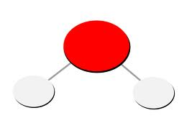

- Explain why water molecules have these polar charges and where the Hydrogen bonds form.

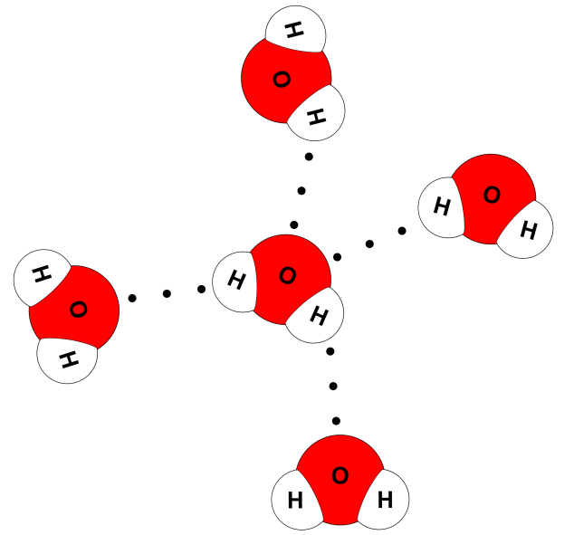

- The Hydrogen bonds of water give water itself three important properties essential to all living organisms. What are these three properties and describe each

  - .
  - .
  - .

Topic: Carbon Properties

- Carbon is said to be the element essential for life. It is a very important element due to its ability to __________________________________________________________.

- What are the 4 Carbon based molecules found in all living organisms? List each and write a brief description of the function each molecule has. Also sketch an image of what a monomer of each molecule will look like.

Topic: Solutions/mixtures
- Define solution:
- Define solvent:
- Define Solute:
- Sketch an image and label the solution, solute, and solvent.

- Some compounds break up when they dissolve in water. The amount of H+(hydrogen ions) a solution contains is measured by what scale?

- Sketch the pH scale and explain which direction from neutral 7 would be an acid and which direction from neutral 7 would be a base. (Know what the H+ concentration will be of each).

Topic: Chemical Reactions
- Define Chemical Reactions:
- Chemical equations are used to show what happens during a chemical reaction. Look at the example below and label the different parts. (Reactants, direction of reaction, and products)
6CO₂ + 6H₂O C₆H₁₂O₆ + 6O₂

- If a reaction has a double arrow (one pointing in both directions) what does this represent?
- Define Activation Energy:
- Define Endothermic Reactions:
- Define Exothermic Reactions:

Topic: Enzymes
- Enzymes are catalysts. Define Catalyst:

- What affect do enzymes have on chemical reactions?

- Define Substrates:

- What and/or how does a change in temperature or a change in pH, change how an enzyme may work?

